Name: Mohamad Akmal Bin Zulkefle

Matric: 280812

Home GUI

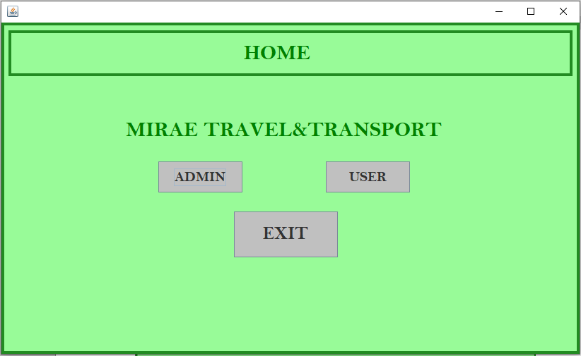

(Choose Admin)

Login for Admin GUI

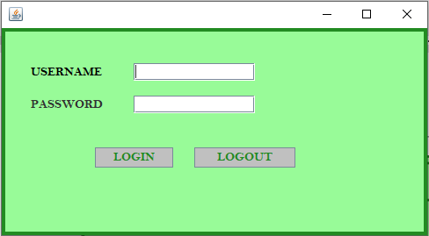

Admin Menu GUI

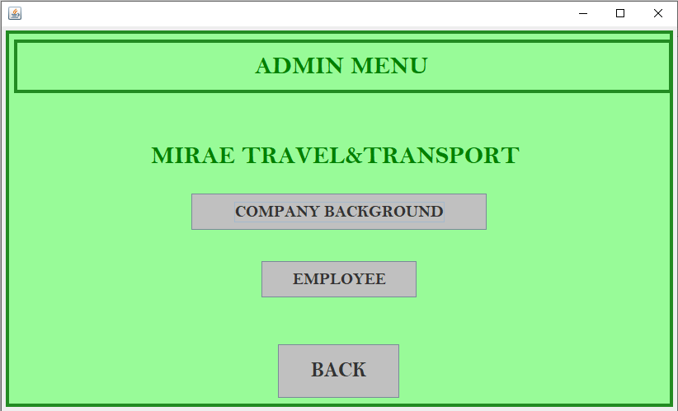

Company Background GUI (for Admin and User)

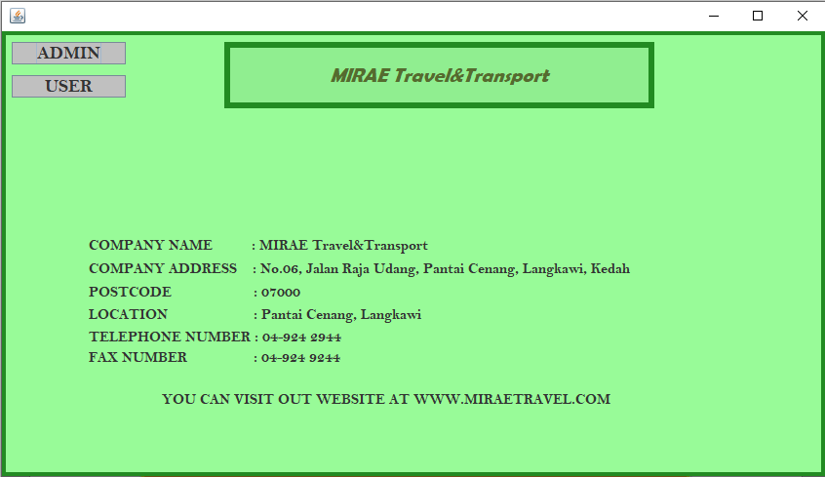

(Click “USER” to go back to User Menu)

Employee Management GUI  
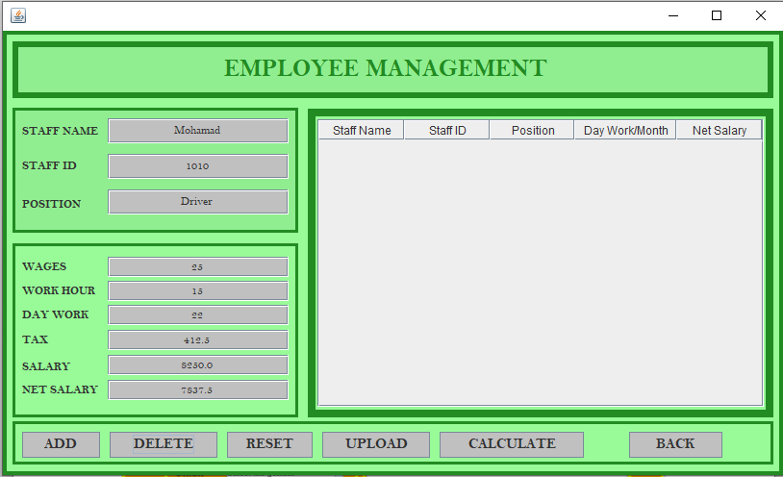

(Back to Home)



(Choose User)

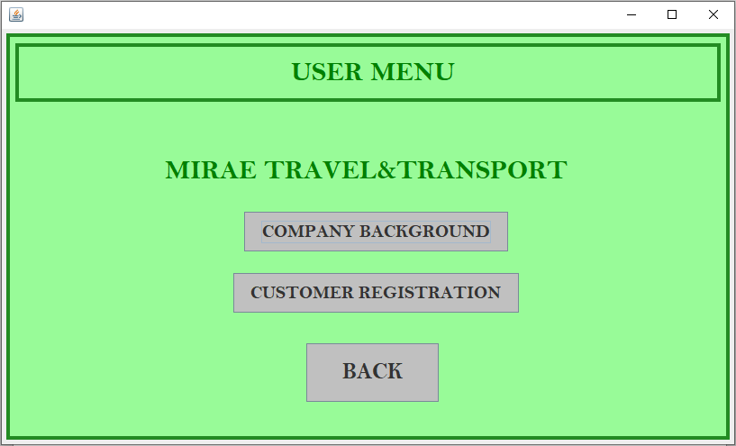

Company Background GUI (for Admin and User)



(Click “USER” to go back to User Menu)

Customer Registration GUI

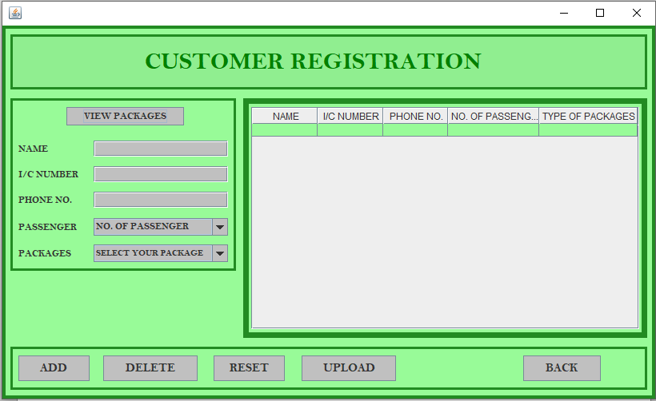

Click “VIEW PACKAGES” to open Type Of Packages GUI

